19) Write a C program to arrange a series of numbers using Quick Sort

PROGRAM:

#include <stdio.h>

void swap(int\* a, int\* b) {

int t = \*a;

\*a = \*b;

\*b = t;

}

int partition(int arr[], int low, int high) {

int pivot = arr[high];

int i = (low - 1);

for (int j = low; j <= high - 1; j++) {

if (arr[j] < pivot) {

i++;

swap(&arr[i], &arr[j]);

}

}

swap(&arr[i + 1], &arr[high]);

return (i + 1);

}

void quickSort(int arr[], int low, int high) {

if (low < high) {

int pi = partition(arr, low, high);

quickSort(arr, low, pi - 1);

quickSort(arr, pi + 1, high);

}

}

int main() {

int arr[] = {10, 7, 8, 9, 1, 5};

int n = sizeof(arr) / sizeof(arr[0]);

quickSort(arr, 0, n - 1);

printf("Sorted array: ");

for (int i = 0; i < n; i++) {

printf("%d ", arr[i]);

}

return 0;

}

INPUT:

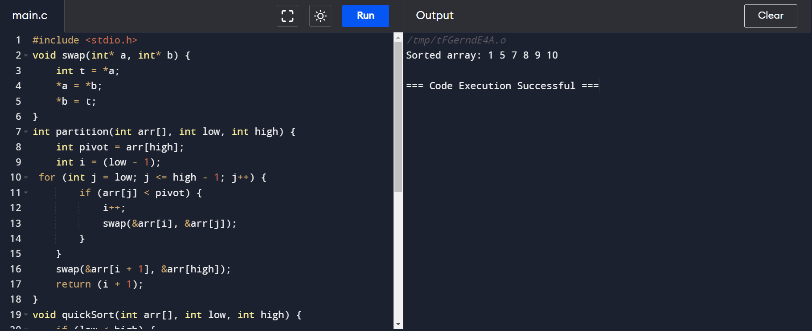

OUTPUT:

